The ileocecal valve of the ileum (small intestine) passes material into the large intestine at the:
A. Colon
B. Cecum
C. Rectum
D. Ileum
ANSWER: B
Material passes through the ascending, transverse, descending and sigmoid portions of the
A. Colon
B. Cecum
C. Rectum
D. Ileum
ANSWER: A
The Colon is about long
A. 1.0 to 1.2m
B. 1m
C. 1.5 to 1.8m
D. 2.0 to 2.5m
ANSWER: C
The colon consists of how many parts?
A. 1
B. 2
C. 3
D. 4
ANSWER: D
The _________is the first section of the large intestine
A. Colon
B. Cecum
C. Rectum
D. Ileum
ANSWER: B
The __________ is the last section of the large intestine
A. Colon
B. Cecum
C. Rectum
D. Ileum
ANSWER: C
Distention of the rectal wall by faeces acts as a stimulus that initiates the
A. Local reflex
B. Defaecation reflex
C. Action reflex
D. Monosynaptic reflex
ANSWER: B
________action causes weak contractions of the rectum and relaxation of the internal anal sphincter
A. Local reflex
B. Defaecation reflex
C. Action reflex
D. Monosynaptic reflex
ANSWER: A
The external anal sphincter, which is composed of
A. Smooth muscle
B. Cardiac muscle
C. Skeletal muscle
D. None of these
ANSWER: C
In infants, the _________reflexes cause automatic emptying of the lower bowel
A. Ingestion
B. Inoculation
C. Assimilation
D. Defaecation
ANSWER: D
The defecation reflex triggers the _______main sphincters around the anal canal
A. Two
B. One
C. None
D. Five
ANSWER: A
The ____________is under conscious cerebral control and prevents the movement of feces out of the rectum and through the anal opening
A. Internal anal sphincter
B. External anal sphincter
C. Both A and B
D. None of these
ANSWER: B
The _________is responsible for the temporary storage of feces before defecation
A. Large intestine
B. Urethra
C. Rectum
D. Anus
ANSWER: C

Which of the following is a metabolic centre?
A. Liver
B. Heart
C. Lung
D. Bone
ANSWER: A
Liver is located in:
A. Abdomen
B. Thorax
C. Buccal cavity
D. None of these
ANSWER: A
Sac like ________ is attached for the storage of bile secreted by liver.
A. Pancreas
B. Intestine
C. Gall bladder
D. Kidneys
ANSWER: C
If glucose is in excess, it is converted into:
A. Starch
B. Cellulose
C. Glycogen
D. Amino acid
ANSWER: C
Deamination is:
A. Removal of amino group
B. Addition of amino group
C. Removal of glycogen
D. Addition of glycogen
ANSWER: A
A hepatocyte is a cell of:
A. Kidney
B. Heart
C. Liver
D. Thymus
ANSWER: C
Which of the following vitamins is stored in the liver?
A. Vitamin K
B. Vitamin D
C. Vitamin E
D. All of these
ANSWER: D
Which protein is produced by the liver?
A. Albumin
B. Keratin
C. Sceleroprotein
D. Globular protein
ANSWER: A
Which of the following is the function of the human liver?
A. Production of bile
B. Metabolism of fats
C. Metabolization of carbohydrates
D. All of these
ANSWER: D
Largest gland present in the human body is:
A. Pancreas
B. Liver
C. Pituitary gland
D. Thyroid gland
ANSWER: B
Glucose is stored in the liver as:
A. Starch
B. Cellulose
C. Glycogen
D. Cellulose
ANSWER: C
Bile is produced by:
A. Pancreas
B. Liver
C. Thyroid gland
D. Aorta
ANSWER: B
Bile salts acts as an activator of which of the following enzyme?
A. Lipase
B. Pepsinogen
C. Pancreatic lipase
D. Trypsin
ANSWER: A
Where is the Glisson capsule found?
A. Liver
B. Heart
C. Kidneys
D. Stomach
ANSWER: A
The formation of glycogen from glucose is called
A. Glycolysis
B. Gluconeogenesis
C. Glycogenesis
D. Glycogenolysis
ANSWER: C
The Head of the ___________ is connected to the duodenum part of the small intestine for the secretion of different juices in the small intestine.
A. Pancreas
B. Heart
C. Liver
D. Spleen
ANSWER: A
The ________is a complex organ composed of both endocrine and exocrine tissues that perform several functions
A. Pituitary
B. Thyroid
C. Pancreas
D. Thymus
ANSWER: C
The pancreas consists of a____________, located within the curvature of the duodenum
A. Body
B. Tail
C. Head
D. Neck
ANSWER: C
The endocrine part of the pancreas consists of
A. Pancreatic islets
B. Islets of Langerhans
C. Both A and B
D. None of these
ANSWER: C
The exocrine secretion of the pancreas is called
A. Pancreatic juice
B. Tail
C. Pancreatic islets
D. Islets of Langerhans
ANSWER: A
The major proteolytic enzymes are:
A. Trypsin
B. Chymotrypsin
C. Carboxypeptidase
D. All of these
ANSWER: C
In the pancreas, the antidiabetic hormone-Insulin is secreted by the …………………… Cells.
A. Beta cells
B. Delta cells
C. PP cells
D. Alpha cells
ANSWER: D
The enzymatic component of the pancreatic juice is produced by the _________ of the pancreas
A. Aqueous bicarbonate component
B. Duct cells
C. Acinar cells
D. Epithelial cells
ANSWER: C
The pancreas is an organ that in humans lies in the
A. Head
B. Thorax
C. Abdomen
D. None of these
ANSWER: C
Anatomically, the pancreas is divided into:
A. head, tail
B. head, neck, body, tail
C. neck, body, tail
D. head, neck
ANSWER: B
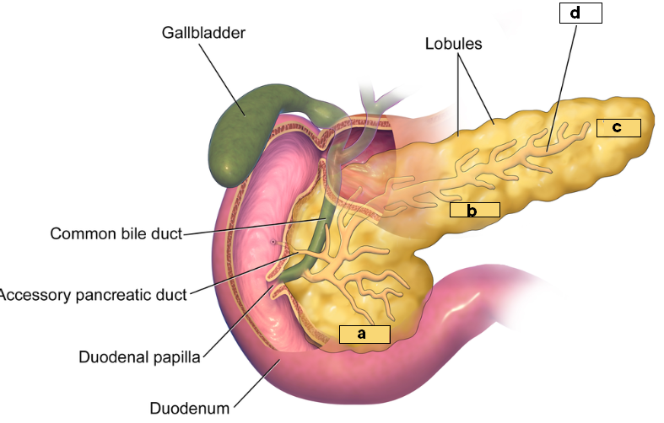
Observe the diagram and identify what “a” represents:
A. Head
B. Neck
C. Body
D. Tail
ANSWER: A

Observe the diagram and identify what “b” represents:
A. Head
B. Neck
C. Body
D. Tail
ANSWER: C

Observe the diagram and identify what “c” represents:
A. Head
B. Pancreatic duct
C. Body
D. Tail
ANSWER: D

Observe the diagram and identify what “d” represents:
A. Head
B. Pancreatic duct
C. Body
D. Tail
ANSWER: B
The pancreatic duct joins the common bile duct to form the
A. Duct of Wirsung
B. Ampulla of Vater
C. Collecting duct
D. None of these
ANSWER: B

